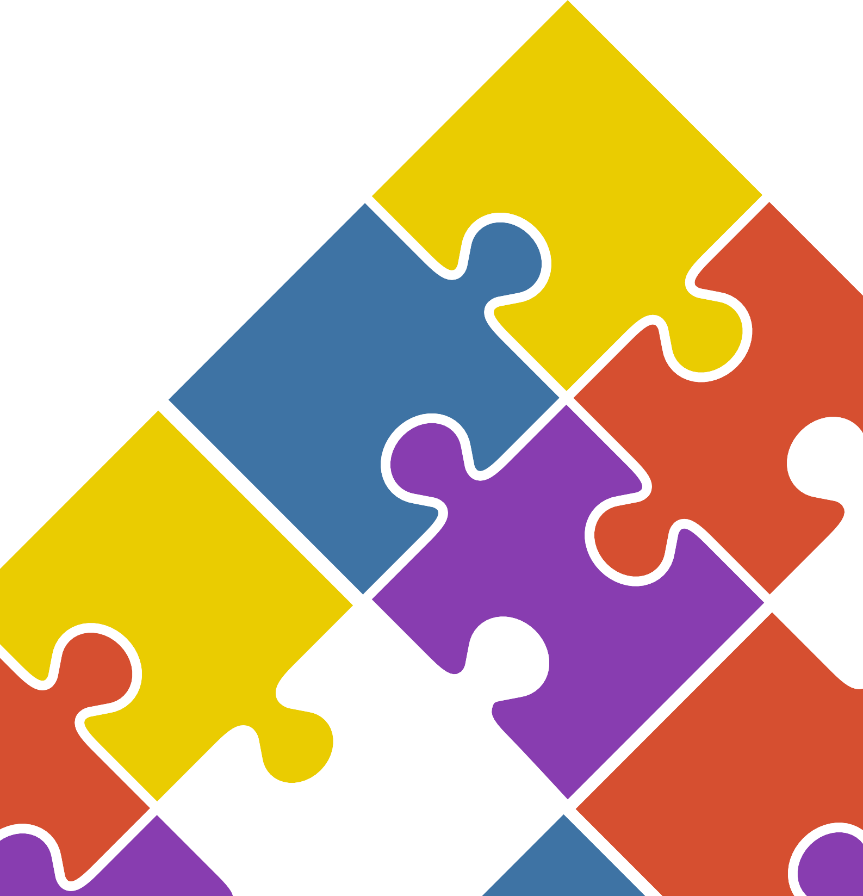

National Independent Safeguarding Board Wales

Annual Report
2015 –16
including easy read summary

Contents
Introduction 5
- To provide support and advice to Safeguarding Boards with a view
to ensuring that they are effective 7
- To report on the adequacy and effectiveness of arrangements
to safeguard children and adults in Wales 11
- To make recommendations to the Welsh Ministers as to how those
arrangements could be improved 13
  - Definitions of abuse, neglect, harm and risk 15
  - The Potential of Safeguarding 17
  - The Social Services and Well-Being (Wales) Act 2014, the
Well-being of Future Generations Act 2015 and the Violence Against
Women, Domestic Abuse and Sexual Violence (Wales) Act 2015 23
Membership of the National Independent Safeguarding Board 27
Appendix 1: Notes from NISB’s consultation with the Chairs of
Safeguarding Boards and leads from CSSIW and HIW on 23 August 2016 31
Appendix 2: The interface of the Social Services and Well-being (Wales) Act 2014 and with (i) the Mental Capacity Act 2005 and (ii) the Criminal
Justice and Courts Act 2015 35
Acknowledgements 37

This is the first report of the National Independent Safeguarding Board.
It is also known as the National Board.
The National Board has six Board Members. They all work part time.
The National Board must: -
Help the Safeguarding Boards in Wales
to work well.

Report on how well they protect people from being abused.
Tell the Welsh Government how the work
of the Safeguarding Boards could be better.

Introduction

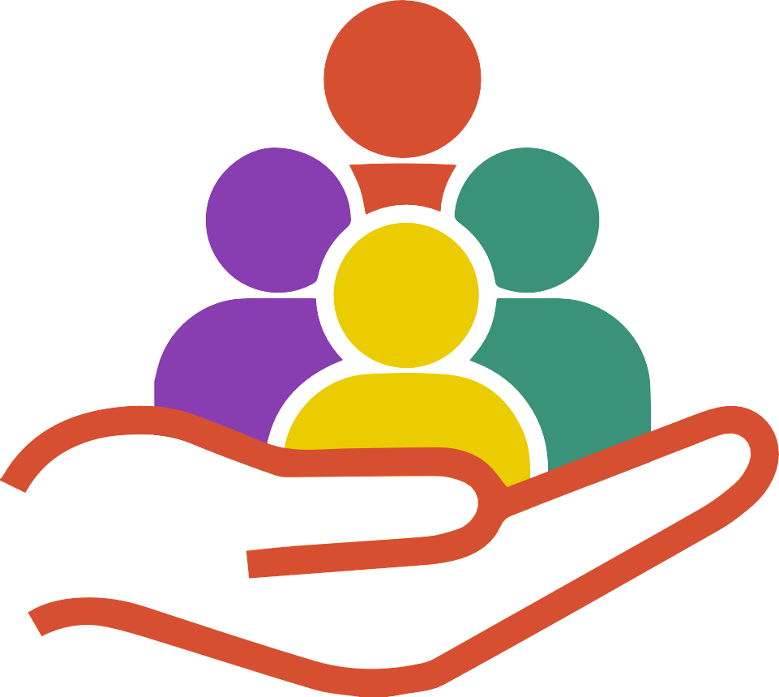

This is the first Annual Report of the National Independent Safeguarding Board set up under the Social Services and Well-being (Wales) Act 2014. Specifically, the National Board has three primary duties. These are:
- To provide support and advice to Safeguarding Boards with a view to ensuring that they are effective
- To report on the adequacy and effectiveness of arrangements to safeguard children and adults in Wales

To make recommendations to the Welsh Ministers as to how those arrangements could be improved (S.132 (2)).

The regulations made under the 2014 Act set out the way in which the National Board must exercise its functions. An important function is the requirement to consult with those who may be affected by arrangements to safeguard children and adults in Wales.1
The National Board works on a part-time basis. Its six members are expected to work at least a day a month on National Board matters.

- Regulation 7 of The National Independent Safeguarding Board (Wales) (No.2) Regulations 2015

The National Board talks to many people.
Some of them may have suffered abuse and harm.
The National Board has to make sure all Safeguarding Boards work well in Wales.
Local Children’s safeguarding boards have always involved: -
- The Police
- Social Services

National Health Service
It is important that professionals and
managers work together.

This makes it more likely that they will succeed.
It is important that Safeguarding Board Members do as much as they can to: -
- Protect children, young people and adults
- and stop them from being harmed.
If managers work together they are more powerful.
This means they are more likely to make people safe.

1. To provide support and advice to Safeguarding Boards with a view to ensuring that they are effective

The role of Local Safeguarding Children Boards (LSCBs) to date has been to safeguard and promote the welfare of children and young people in their area. LSCBs have always aimed to promote multi- disciplinary working among the LSCBs’ membership, most particularly in relation to the police and the NHS. Welsh Government Guidance2 sets out (i) how the relevant agencies and professionals should work together to protect children from harm, and (ii) how the LSCBs are to coordinate this work.
During 2008, the Care and Social Services Inspectorate3 provided evidence of improvements in child safeguarding but identified joint working arrangements as requiring attention, most particularly in terms of the participation of senior managers. It also found that too much reliance was being placed on social services departments to ensure the coordination of safeguarding functions. During 2009, the Health Inspectorate Wales4 confirmed the alertness of NHS staff to child protection matters, as well as to concerns about sharing information within and beyond its own organisations. However,
an inspection of LCSBs5 during 2009 found that, “generally LSCBs are not effectively fulfilling their responsibilities as set out in section 31 (1) of the Children Act 2004…” (para 8).
The Welsh Government issued In Safe Hands in 2000, with the aim of developing multi-disciplinary working, and monitoring and responding to concerns about adult abuse. Valuable as the processes advanced by this guidance have been, it only related to vulnerable adults, that is, those who are, or may be in need of community care services. The Protection of Vulnerable Adult Project Board established during 2008 further recommended that the protection of vulnerable adults should be underpinned by legislation and that new guidance was required for local authorities, health boards and trusts and all agencies involved in adult protection activities. This was endorsed by the Welsh
Institute for Health and Social Care and the University of Glamorgan’s 2010 review of In Safe Hands. The 2014 Act established Safeguarding Children Boards and Safeguarding Adults Boards,6 regulated by new secondary legislation and guided by the Code to Part 7.

- Safeguarding Children: Working Together Under the Children Act 2004
- Safeguarding and Protecting Children in Wales: the review of Local Authorities and the Local Children Safeguarding Boards
- Safeguarding and Protecting Children in Wales: A review if the arrangements in place across the Welsh National Health Service
- by the Care and Social Services Inspectorate Wales, the HealthCare Inspectorate Wales, HM Inspectorate for Education and Training in Wales (Estyn), HM Inspectorate of Probation and HM Inspectorate of Constabulary
- They are regulated by new secondary legislation and guided by the Code to Part 7 of the 2014 Act

The Social Services and Well Being (Wales) Act wants to protect everyone from abuse or harm.

The Safeguarding Boards have to make sure that is being done properly.

The 2014 Act provides the statutory objectives of the Safeguarding Boards, that is, in relation to children:
- “To protect children within its area who are experiencing, or are at risk of, abuse, neglect or other kinds of harm, and
- To prevent children from within its area becoming at risk of abuse, neglect or other kinds of harm” (S.135 (1))
and in relation to adults:
  - “To protect adults within its area who –
    - Have needs for care and support (whether or not a local authority is meeting any of those needs), and
    - Are experiencing, or are at risk of, abuse or neglect, and
  - To prevent those adults within its area … from becoming at risk of abuse or neglect” (S.135 (2)).
The 2014 Act also states that a Safeguarding Board, “must seek to achieve its objectives by coordinating and ensuring the effectiveness of what is done by each person or body represented on the Board” (S.135 (3)); to set out its proposals for achieving its objectives at the beginning of each financial year (S.136 (1)); and “co-operate with the National Board and…supply the National Board with any information it requests” (S.139 (1)).
Each Safeguarding Board is expected to identify and benchmark the areas of practice which require improvement. The statutory guidance states that one of the functions of the Safeguarding Boards
is “to review the training needs of those practitioners working in the area of the Board in order to identify training activities and to provide and to ensure training is provided on an interagency and individual organisational basis to assist in the protection and prevention of abuse and neglect of children and adults at risk of harm in the area of the Board” (para.113 (j)).

The National Board will be asking the Safeguarding Board for information.

Every year the Safeguarding Boards have to report: -
- What they have done.
- What they are going to do.
- How they are supporting each other to make people
safe.

The National Board will report on how well Safeguarding Boards are keeping people safe.
The National Board knows that the Safeguarding Boards have a lot of

responsibility.
Sometimes it is not possible to keep everyone safe.
The National Board started its work in April 2016.
Next year it will ask the Safeguarding Boards about: -
- What they are doing.
- What they are learning.

2. To report on the adequacy and effectiveness of arrangements to safeguard children and adults in Wales

In relation to the Safeguarding Boards, the role of the National Board is advisory only. It is neither supervisory nor hierarchical. The National Board is however aware of the challenges facing Safeguarding Boards:
- delays in the implementation of guidance
- unfunded safeguarding practice
- “Is it poor practice or neglectful practice?”
- not all abuse can be resolved through legal means
- the need for well trained and supervised staff
[See Appendix 1 for the Safeguarding Board Chairs’ contribution and that of the CSSIW and HIW to the above.]
Although the National Board technically came into being during November 2015, it did not become operational until 6 April 2016. Hence it is not yet possible to report properly on the adequacy and effectiveness of arrangements to safeguard children and adults. However, in order to meet these objectives, the National Board intends to gather information and data on:
- policy and procedures and the appropriateness and consistency of their application
- the consistency of safeguarding training
- how Safeguarding Boards are fulfilling their statutory functions
- information sharing and best practice
- the effectiveness and consistency of learning from all types of reviews and investigations
- the consistency of application of Adult Protection and Support Orders and their effectiveness in improving safeguarding adults at risk
- the child and adult protection interface (para. 262, Part 7 Guidance on Safeguarding). In relation to the above, the National Board will determine:
- What information it needs to collect
- How it is to provide advice and support
- How it is to consult, with whom and to what purpose
- How the people known to Safeguarding Boards, and their relatives, may be able to contribute.
It is envisaged that this will provide the National Board with a baseline from which adequacy and effectiveness can be measured and improvements recommended.7

- As set out in Regulation 8 of the 2015 Regulations

The National Board is deciding what information it should collect.
They are thinking about how they should work with people who: -
  - Are being harmed.
  - Who are at risk of being harmed.
The National Board will then tell the Welsh Government how they think things could be better.
The Safeguarding Boards will print their first reports in 2017.
The National Board will read all of these reports.
This will help it to understand how well the Safeguarding Boards are
doing what they should be doing.
The National Board will point out similar kinds of information - sometimes called trends or themes.
This will help the National Board to learn about what changes will be helpful to make people safer.
The report explains what the Social Services and Well Being (Wales) Act
means by Safeguarding.

3. To make recommendations to the Welsh Ministers8 as to how those arrangements could be improved

In due course the National Board’s Annual Reports will include information about the work and outcomes achieved by the Safeguarding Children Boards and the Safeguarding Adult Boards. However, since these Boards are not required to publish their Annual Reports until July 2017, the National Board will take the opportunity in the interim to highlight the implications of the Social Services and Well-being (Wales) Act 2014 for safeguarding through the following:
- definitions of abuse, neglect, harm and risk
- the potential of safeguarding
- the Social Services and Well-Being Act 2014, the Well-being of Future Generations Act 2015 and the Violence Against Women, Domestic Abuse and Sexual Violence (Wales) Act 2015
- the interface of the Social Services and Well-being (Wales) Act 2014 and with (i) the Mental Capacity Act 2005 and the Criminal Justice and Courts Act 2015 and (see Appendix 2)
This knowledge base will enhance the recommendations which the National Board will be able to make to Welsh Ministers on the adequacy and effectiveness of the safeguarding arrangements and whether or not these could be improved.

- That is the Cabinet Secretary for Communities and Children, the Cabinet Secretary for Education, the Cabinet Secretary for Health, Well-being and Sport, and the Minister for Social Services and Public Health

The report deals with: -
Abuse
This means hurting a person.
Abuse can be happen when a person is hit, trapped, hated or left.
It can be when a person is made to do something sexual that they
don’t want to do.
It can be about hurting a persons feelings or making them feel bad
about themselves.
Neglect
This is when a person’s needs are not being met.
Harm
This is about damage or hurt caused to a person’s body.
It also includes hurting person’s feelings.

If a person is described as being at risk it means: -
  - They are being abused or neglected.
  - They might be abused or neglected.
  - They can’t protect themselves.

a. Definitions of abuse, neglect, harm and risk
The 2014 Act identifies “protection from abuse and neglect” as an essential element of well-being (S.2). It defines abuse in S.197 as “physical, sexual, psychological, emotional or financial…(and includes abuse taking place in any setting, whether in a private dwelling, an institution or any other place), and ‘financial abuse’ includes –
- Having money or other property stolen;
- Being defrauded;
- Being put under pressure in relation to money or other property;
- Having money or other property misused.”
Examples of each type of abuse and neglect are set out in the statutory guidance (para. 26).
S.197 defines neglect as “a failure to meet a person’s basic physical, emotional, social or psychological needs, which is likely to result in an impairment of the person’s well-being (for example, an impairment of the person’s health, or in the case of a child, an impairment of the child’s development.”
The definitions of abuse and neglect apply to both children and adults.
The avoidance of harm is also crucial to the concept of safeguarding in relation to children:
“Harm” in relation to a child means abuse or the impairment of (a) physical or mental health or
(b) physical, intellectual, emotional, social or behavioural development and where the question of whether “harm” is significant turns on the child’s health or development is to be compared with that which could reasonably be expected of a similar child (S.197).
A “child at risk” is “a child who (a) is experiencing or is at risk of abuse, neglect or other kinds of harm, and (b) has needs for care and support (whether or not the authority is meeting any of those needs” (S.130 (4)).
Section 130 imposes a “duty to report” on partner agencies in relation to a “child at risk.”
The duty to make enquiries under S.47 of the Children Act 1989 remains in force and is unaltered by the 2014 Act (S.130 (6)).
Section 126 (2) of the 2014 Act requires a local authority to make enquiries and decide whether any action should be taken if it has reasonable cause to suspect that an adult within its area is at risk. An adult at risk is defined as one “who (a) is experiencing or is at risk of abuse or neglect, (b) has needs for care and support (whether or not the authority is meeting any of those needs) and, (c) as a result is unable to protect himself or herself against the abuse or neglect or the risk of it” (S.126 (1)).
A “duty to report” is imposed on partner agencies where there is reasonable cause to suspect that an adult may be at risk (S.128).
The 2014 Act makes no reference to “eligibility criteria” or “thresholds” in relation to risk. This is deliberate. The varieties of abuse are so considerable it is possible that some examples would fall outside tightly prescribed criteria.

The Social Services and Well Being (Wales) Act says that all professionals must report anyone they think might be at risk to their local authority.
This is part of Safeguarding.
Safeguarding is about ways of stopping people from being abused or neglected before it happens.
This stops them having bad experiences.

These bad experiences can have a bad affect on young people as they grow up into adults.
The National Board and the Safeguarding Boards want to stop this.
Professionals can only do something about abuse or neglect if they know

that it is happening.
This is why the message TELL SOMEONE is so important.

b. The Potential of Safeguarding
The National Board recognises that the requirement to prevent harm is one of the most difficult of all human activities. For example, research by Public Health Wales9 shows that abuse is associated with a spectrum of longer term disruption ranging from the milder symptoms of distress through to substance misuse problems, mental health challenges and suicide. It follows that the consequences of abuse reach beyond individual suffering and have considerable human and economic costs.
Nevertheless, there has been an increase in public awareness of different types of abuse and more recently, child sexual exploitation, trafficking, scamming and coercive control are becoming part of our vocabulary. That is, as the public perception of these terms becomes greater so the expectations of safeguarding also increase and a realistic approach is required. The disclosure of individuals’ expressing concern, plus professional cooperation, are both essential to make safeguarding effective. Also essential is the gathering of data concerning people’s experience of harm – even though its significance and impact is limited to that which is known.
The media has made a considerable contribution in revealing the extent of different forms of abuse by promoting awareness of the context of abuse and neglect such as:
- Out of control temper
- The use of physical force such as smacking
- Exploitation of people’s physical and mental vulnerability
- Alcohol and substance abuse
- Breakdown of relationships

- http://www.wales.nhs.uk/sitesplus/888/news/40000 (accessed 26 October 2016)

A lot of professionals are collecting information. This will help them: -

Treat people’s pain and injuries.
  - Challenge Services.
  - Take offenders to court.

There are very positive examples of how people working in hospitals, social services and schools have prevented abuse.

There are positive examples of children, young people and adults have been brave and told others about the ways they have been hurt.

However, these are partial glimpses of the complete picture. We have to rely on professionals to provide the fuller context. The role of gathering and sieving facts and establishing their reliability must be for the police, lawyers, regulators, coroners, researchers, health professionals and social care professionals. Examples of valuable interventions which have had positive consequences include:
- paediatric radiologists who questioned whether multiple long bone fractures and subdural haematomas might have been inflicted by parents;
- social workers, mental health and youth offending practitioners, psychologists, psychiatrists and researchers who confirmed that violence and abuse may have long term impacts on mental health;
- midwives, nurses and teachers who noted that infants and children who were not protected from the violence and other abuses in their family homes might struggle to learn and behave in ways which signal distress;
- regulators and inspectors who highlighted the challenge of working with home owners who deny that there is anything wrong with their homes.

However, others have also made valuable contributions to the gathering and sieving of facts:
- women of all ages, and more recently men, who themselves had the confidence to draw attention to their experience domestic violence;
- young adults brought up “in care,” particularly those who have not been able to settle, demonstrating how they may be at continuing risk of exposure to harm;
- survivors, whistle-blowers and relatives whose accounts of abuse by adults and/ or by peers in institutional settings who show how, in closed environments, bullying, neglect, physical and sexual assaults may take root and thrive;
- young people who revealed the normalisation of bullying in society, including cyber-bullying and online sexual exploitation, which shamed and confused them and affected their sense of worth;
- older people who shared their experience of the destructive impacts of intergenerational violence could not be simplified by the unhelpful term “granny bashing;”
- testimony from self-help organisations which has increased our understanding of the complexity of abuse.

We are learning from school children, young people and the relatives of people who have been harmed.
They want to make sure that what has happened to them does not happen to anyone else.

More recently in Wales:
- it was “The Cardiff Model for Violence Prevention”10 which has helped the police to use Accident and Emergency data to pinpoint where a crime is taking place and allows police to focus their resources;
- it was school-girls who resisted the sexual harassment of their peers which resulted in distributing imaginative Valentine’s Day cards to all members of the Senedd;11
- it was the Minister for Health and Social Services who instigated a series of pan-Wales workshops arising from the publication of In Search of Accountability: A review of the neglect of older people living in care homes investigated as Operation Jasmine;
- it was bereaved relatives who shared their attempts to understand the impact of coercive control that their loved ones endured;12
- it was the NSPCC which drew together learning from reviews of children and young people who have been harmed and highlighted the challenges of measuring the extent of abuse and neglect across the UK countries;13
- it was Mair Elliott and Jake Roberts who wrote a response to the “Together for Children and Young People” Programme: Making Sense: a report by young people on their well-being and mental health;14
- it was Public Health Wales’ national survey of Adverse Childhood Experiences in Wales15 which confirmed the role of systematic and community based approaches to tackling such experiences as well as the health and economic value of good parenting.
The Independent Inquiry into Child Sexual Abuse (IICSA) chaired by Professor Alex Jay has now opened its Wales office. Through its Truth Project, Public Hearings Project and Research Project it will carry out an investigation into past and present failings by institutions to protect children from sexual abuse. It will hold those responsible to account, and make recommendations to protect future generations of children.
Such developments and shifts in the safeguarding landscape have more than curiosity value. They point to positive impacts for individuals and professional practice and they map very closely onto the Social Services and Well-being (Wales) Act.

- http://www.college.police.uk/News/Newsletter/January2015/Documents/CoP_AE_Guidance_report_final.pdf (accessed 12 August 2016)
- www.youtube.com/watch?v=tZ3Jkq8QlF8 (accessed 5 July)
- www.youtube.com/watch?v=Tx0-A6jqFWA&app=desktop (accessed 5 July 2016). In this interview, Gwyneth Swain, the mother of Kim Buckley (aged 46), the grandmother of Kayleigh (aged 17) and the great grandmother of Kimberley (age 6 months) explains that her granddaughter met her partner online and that the family knew nothing of his violent history. He controlled her granddaughter and became jealous of their baby. He set fire to their home and watched as efforts to save Kim, Kayleigh and Kimberley were unsuccessful. Gwyneth’s message to services was “Ask how you can help”
- Bentley, H., O’Hagan, O, Raff, A. and Bhatti, I. (2016) How safe are our children? London: NSPCC
- http://www.hafal.org/wp-content/uploads/2015/06/A-report-by-young-people-on-their-well-being-and-mental-health.pdf (accessed 23 October 2016)
- Professor Mark Bellis and colleagues

The Social Services and Well Being (Wales) Act 2014. The Future Generations Act 2015.
Violence Against Women Domestic Abuse and Sexual Violence Act 2015.

?
Together, these laws aim to make sure that people may make choices or are helped to do so. Professionals must think about people’s futures and do all that they can to prevent people from being hurt and help people who have been hurt.

It wants to: -
- Support people as part of families and communities.
- Give them voice and control.
- Improve services.

c. The Social Services and Well-Being (Wales) Act 2014, the Well-being of Future Generations Act 2015 and the Violence Against Women, Domestic Abuse and Sexual Violence (Wales) Act 2015
The 2014 Act came into full force on 6 April 2016. It repealed or dis-applied the pre-existing community care legislation in Wales.16
The intention of the 2014 Act is to integrate social services to support people of all ages, and support people as part of families and communities - the “people” approach. It is intended to transform the way social services are delivered, primarily through promoting people’s independence to give them a stronger voice and control. It is expected that the integration and simplification of the law will provide greater consistency and clarity to people who use social services, their carers, local authority staff, their partner organisations, the court and the judiciary. The stated intention
of the Act is to promote equality, improvements in the quality of services and the provision of information people receive. There is to be a shared focus on prevention and early intervention. The 2014 Act concentrates on delivering outcomes for individuals and improving the individual’s well-being. As part of that new scheme, the new duties to report adults and children at risk – S.126 and S.130 – are brought into being, as are the new Adult Protection and Support Orders - S.127.
New Safeguarding Adult Boards and Safeguarding Children Boards are formed, the National Independent Safeguarding Board is introduced and new duties are imposed to ensure co-operation between agencies.17 Safeguarding is intended to be improved by the implementation of these sections. Nothing within the Act is intended to undermine or detract from duties and powers in other legislative schemes which are designed to protect children and adults.18
That is, the protective provisions of the Children Act 1989 remain in force and the remaining provisions of the Children Act 1989 co-exist with the 2014 Act.19 A child who is in need of protection under the Children Act 1989 may also be a child in need of care and support under Parts 3 and 4 of the 2014 Act. Equally the duties and functions of Welsh social services authorities to all looked after and accommodated children are prescribed by Part 6 of the 2014 Act.

- Parts 3 and 4 of the National Assistance Act 1948 • Section 3 of the Disabled Persons (Employment) Act 1958 • Section 45 of the Health Services and Public Health Act 1968 • Sections 1, 2 and 28A of the Chronically Sick and Disabled Persons Act 1970 • Section 17 of the Health and Social Services and Social Security Adjudications Act 1983 • Sections 3, 4 and 8 of the Disabled Persons (Services, Consultation and Representation) Act 1986 • Section 46 of the National Health Service and Community Care Act 1990 (NB section 47 of the 1990 Act is being amended so that it does not apply to assessing and meeting needs for community care services in so far as this is now provided for in the 2014 Act but it will continue to apply to assessing and meeting needs for services under section 117 of the Mental Health Act 1983) • Carers (Recognition and Services) Act 1995
- Carers and Disabled Children Act 2000 • Sections 49, 50, 54, 56 and 57 of the Health and Social Care Act 2001 • Section 16 of the Community Care (Delayed Discharges etc) Act 2003 • Carers (Equal Opportunities) Act 2004 • Section 192 of and Schedule 15 to the National Health Service (Wales) Act 2006 • Personal Care at Home Act 2010 • Social Care Charges (Wales) Measure 2010 • Carers Strategies (Wales) Measure 2010 (NB this is being repealed as a consequence of the provisions in section 14 of the 2014 Act which require local authorities and Local Health Boards to carry out assessments of the needs of their local population, including the needs of carers).
- See S.167 “Resources for partnership arrangements” for example
- The Regulations made under the 2014 Act repeal Sections 31 – 34 of the Children Act 2004. The 2014 Act repealed Part III and Schedule 2 of the Children Act 1989 in Wales (although they remain in force in England). Nothing within the 2014 Act has any significant impact on the remainder of the 1989 Act. In particular, nothing alters the protective provisions of the Children Act 1989 found principally in Parts IV and V of the 1989 Act. Section 47 Children Act remains in force - as do Sections 31 and 44 of the 1989 Act.
- Part III of the Children Act 1989 no longer applies in Wales

The new laws replace some old laws.
The new laws fit in well with some old laws.
It is a bit like a jigsaw, which has many
different pieces.

In Wales strategic laws have been implemented which are intended to change the way we think as a Nation and to improve the well-being of the populace of Wales. The Well-being of Future Generations Act 2015 is now in force. It is intended that the 2015 Act will make the public bodies
listed in the Act think more about the long term, work better with people and communities and each other, look to prevent problems and adopt a more joined-up approach. This will mean that public bodies must do what they do in a sustainable way. Public bodies when making decisions must take into account the impact they could have on people living their lives in Wales in the future. Hence when, for example, a local authority considers building new schools or recreation facilities or closing libraries, it must now consider not simply the immediate needs of the community it serves but its future needs. The intention is to ensure that the plans made by public bodies improve the future well-being of those who live in Wales.
How Wales responds to abuse and violence is legislated for in the Violence against Women, Domestic Abuse and Sexual Violence (Wales) Act 2015. This Act does not alter the criminal law. However, the Act aims to improve the Public Sector response in Wales to abuse against women, and to improve arrangements to promote awareness of, and prevent, protect and support victims of gender-based violence, domestic abuse and sexual violence. It introduces a needs–based approach to developing strategies which aim to ensure strong strategic direction and strengthened accountability in relation to such acts through the appointment of a Ministerial Adviser whose role involves advising Welsh Ministers and improving joint working amongst agencies across this sector. Joined up service provision is intended to ensure consistency and quality of service provision throughout Wales.
This new Welsh legislation, together with the 2014 Act and the Well-being of Future Generations Act 2015, emphasises a shift in Wales towards meeting the well-being outcomes of individuals and improving the well-being of the nation as a whole. Whether in terms of the well-being of the individual or when looking at the populace as a whole, at the heart of well-being is the need to safeguard adults and children.

Margaret Flynn is the Chair of the National Board. Keith Towler is the Vice Chair.

Membership of the National Independent Safeguarding Board

Margaret Flynn is the Chair. She chaired Lancashire’s safeguarding adults’ board for eight years and recently has led the review of Operation Jasmine into the neglect
of older people living in care homes in Wales. She says “Twenty years ago the child protection and adult protection landscape was very different. We had a few
documentaries, books written by professionals and, very occasionally, autobiographies describing growing up in families which could not protect children and lives in certain institutions which were destructive. I very much hope that the new legislation will help those who are struggling to overcome their history and those who are seeking to help them; make it possible for survivors, their relatives, whistle-blowers and professionals to strengthen and complement the instinctive care we have for each other into something enduring which we can all value.”

Keith Towler is the Vice Chair. Keith was the Children’s Commissioner for Wales between 2008 and 2015. A respected children’s rights expert, he has more than 30 years’ experience in social work, youth work and justice roles. Keith was a member of the Welsh Government’s National Children’s Safeguarding Forum as well as a panel member of the Family Justice Review. He says, “What an exciting opportunity we have to ensure that everyone in Wales feels safer and that those who are vulnerable receive the services and support they need to improve their lives. As a member of the National Board I want practitioners across Wales to take a rights’ based approach
that actively listens to children, young people, vulnerable adults and older people and recognises that good advocacy can help professionals and others to deliver positive outcomes. The Act sets us all a challenge but nothing that’s worthwhile is ever easy!”

Other members of the National Board are: -
- Simon Burch
- Ruth Henke

Jan Pickles
- Rachel Shaw

Simon Burch is a former Director of Social Services and chair of a Regional Safeguarding Children Board. As such, he has recent experience of leading organisations and practitioners to support people at risk of abuse or harm. Simon has a particular interest in domestic abuse and violence against women and the development of safe and fulfilling relationships. He says “Safeguarding to me means two inter-related things: building cohesive, equal and mutually supportive
communities in which we can all flourish and continuing to improve our safeguarding systems so that the voices and aspirations of children and adults at risk drive all of our work. In Wales, we have the people, the legislative framework and the passion to do this if we really listen to what matters to people and trust our staff to work alongside them.”

Ruth Henke QC is an expert in the law relating to adults and children and has acted on behalf of Welsh local authorities, health boards, parents and relatives,
incapacitated adults and children. She says, “As we engage in safeguarding activities we must make sure that the rule of law is observed, that decision-making is evidence based and that we do not lose sight of the bigger picture.”

Jan Pickles OBE is an experienced social worker and has worked in the third sector, the probation service, the police, government and the NSPCC. Jan led the development of the multi-agency risk assessment conference (MARAC), which
makes victims and children who experience domestic and sexual violence and abuse safer. This is now a national model. She says, “Safeguarding is about people – not processes. Unless we collectively strive to deliver valued outcomes for children, young people and adults, no matter how challenging their circumstances, there is no point in processes. To me, safeguarding is about people having choices in their lives and particularly in their relationships - which must be free of inhumane coercion.”

Rachel Shaw is a nurse, midwife and health visitor and brings significant health experience to the National Board. She has contributed to practice reviews as both a reviewer and as a panel chair. She says, “We have learned from people who have
been abused that too many lives are blighted by silent suffering. To feel and be safe is a basic human right across the life course. We have learned also that understanding abuse from the point of view of people who have been harmed gives us insights into
ways of helping people to overcome what has happened to them and inspires all of us to limit the likelihood of others being harmed. We have an opportunity to strengthen and empower individuals, communities and professionals to strive to make such learning central to everything we do.”

The National Board met with the Chairs of the 12 Safeguarding Boards, and

the lead inspectors from the Care and Social Services Inspectorate Wales (CSSIW)
- the lead inspectors from Health Inspectorate Wales (HIW).

They talked about the challenges
of safeguarding people.

The National Board is keen to make sure that safeguarding training is connected to how people are working.

Appendix 1: Notes from NISB’s consultation with the Chairs of Safeguarding Boards and leads from CSSIW and HIW on 23 August 2016

A draft of the National Board’s Annual Report was circulated before the meeting. Attendees were invited to amend/ develop and add to the challenges facing Safeguarding Boards that were set out in the draft. The consultation ranged over the following topics:
- A clear line of sight is required between the Social Services and Well-being (Wales) Act 2014, the statutory guidance and procedures. Concern was expressed that the Welsh Government appears to be elevating procedures over statutory guidance;
- Coordination on a significant scale is required if many hundreds of provider agencies are to credibly engage with the new statutory requirements;
- The introduction of the 2014 Act requires a culture change which will take time. However challenging this is for a single workforce, safeguarding is a multi-agency, multi-partnership, collaborative enterprise. Although local authorities and health boards may be assured of the training of social care and health care staff, safeguarding training opportunities may be unavailable to certain providers;
- There is no simple way of connecting safeguarding training and learning with safeguarding practice or capturing what constitutes good safeguarding in this fragmented but growing specialty;
- The specialism of safeguarding is helpful in terms of gathering political and financial support. However, it is important to dispel the misconception that the responsibility for safeguarding resides solely with specialists;
- The challenges of providing safeguarding services in rural Wales may be overlooked. Rural Wales has a smaller and more dispersed population and workforce compared with urban areas. Also, there may be different Health Board footprints for safeguarding in addition to pressures in terms of geography, travel and meeting attendance;
- There is a tension between children’s and adult safeguarding. Children’s safeguarding may appear to be more mature than adult safeguarding since its legal framework for intervention largely originated with the Children Act 1989. However, prior to the 2014 Act, there was no clear legal framework that recognised adult safeguarding. Other defining differences are considerations of “protection vs autonomy,” mental capacity and the absence of an equivalent role to that of corporate parenting;
- Against the backdrop of sustained financial austerity, it is important to nurture economically safe practice. Currently there are delays in front-line work in terms of initiating strategy meetings and dealing with the unfunded elements of safeguarding such as commissioning practice reviews.
Some Safeguarding Board Chairs are spending a disproportionate amount of time negotiating funding from partner agencies;20

- See statutory guidance for S.138 of the 2014 Act: The recommended funding proportions for Safeguarding Board partners in each Board should be as follows: • local authority 60% (for the local authorities on a Board, there should be a proportionate split based on general population size; • local health boards 25% (where there are two local health boards there should be a proportionate split based on general population size); • police 10%; • probation 5% (probation services includes the National Probation Service and the Community Rehabilitation Companies)

?
The National Board thought about how it could find out about how well Safeguarding Boards make a difference.

It knows that some things can get in the way of providing a good service, such as: -
  - Not reporting people at risk.
  - Having enough time to spend with people who are harmed so that we can learn from what has happened to them.
  - Funding cuts to services.

- Are the Safeguarding Boards and the Regional Boards making a difference? Is there a case for undertaking a cost-benefit analysis of the work of Safeguarding Boards in terms of prevention, responsiveness to referrals and individual outcomes?
- There are a lot of interfaces to negotiate and boundaries to be determined with the inspectorates, Public Service Boards, Community Safety, Domestic Homicide/Child Practice/ Adult Practice Reviews, Families First, Communities First, Supporting People, the professional regulators, complaints, and Disclosure and Barring for example;
- Is there sufficient clarity concerning clinical incidents which have been neglectful? What gets managed in-house/ locally and what is escalated requires transparency;
- There is a distinction to be made between individuals who are at risk of harm and groups of people who are at risk because of the environment in which they receive a service and/ or reside;
- How does a school know where to refer a child about whom there are safeguarding concerns?
The implications of the 2014 Act remain to be set out for education and for school governors in particular. Although education is funded by the public purse, not all school head teachers are receptive to the requirements of children’s safeguarding;
- Engaging with those using safeguarding services is work in progress in most localities. It is resource-intensive because it has to be continuous;
- There is not enough provision for those who have experienced abuse;
- Safeguarding Boards are statutorily required to hold agencies to account but, beyond the Board meetings, what is known about how far this penetrates?
- Interagency working is compromised by (i) the involvement of junior staff who are not in a position to make decisions during Safeguarding Board meetings, (ii) discontinuous Safeguarding Board membership and (iii) the non-involvement of agencies immersed in prevention activities;
- Overviews are not possible if information is treated discretely. What are reviews and safeguarding data telling us? They are established features of the safeguarding landscape. However, unless we look back and consider Serious Case Reviews and inspection reports within a generous timeframe there is a risk of failing to understand the unfolding of safeguarding practice in Wales. If Safeguarding Boards are unclear about (i) sourcing existing information and (ii) information that is required, then safeguarding practice is in danger of being unfocused;
- Alexis Jay and Kathy Somers’ independent review of the Safeguarding Board for Northern Ireland21 underlines the importance of delivering statutory responsibilities.

- https://www.health-ni.gov.uk/publications/independent-review-safeguarding-board-northern-ireland-sbni (accessed 30 August 2016)

The Social Services and Well Being (Wales) Act 2014. The Mental Capacity Act 2005.
Criminal Justice and Courts Act 2015.
The Mental Capacity Act is not affected by the Social Services and Well Being Act.
The Mental Capacity Act is for adults who are not able to make decisions
for themselves.
The Criminal Justice and Courts Act is not affected by the Social Services and Well Being Act.

All of these laws make it clear that EVERYONE HAS A RIGHT TO BE PROTECTED FROM HARM.

Appendix 2: The interface of the Social Services and Well-being (Wales) Act 2014
and with (i) the Mental Capacity Act 2005 and

(ii) the Criminal Justice and Courts Act 2015

The Mental Capacity Act 2005 continues to provide the legislative framework for adults who lack capacity within the meaning of that Act. The 2014 Act co-exists with the 2005 Act. A person who lacks capacity may also be a person who has care and support needs which should or could be met under the 2014 Act. Depending on their circumstances, they may also be an adult at risk within the meaning of S.126 of the 2014 Act.
The criminal law in England and Wales is unaffected by the recent changes in Wales brought about by the 2014 Act. Those who have been abused or neglected or are at risk of abuse or neglect, whether children or adults, are entitled to the full protection of the criminal law. Specific offences have been created over the years to deal with specific situations applicable to those who may be at risk. It is worth emphasising that it continues to be is an offence under S.44 of the Mental Capacity Act 2005 to wilfully mistreat or neglect a person who lacks capacity or who it is believed lacks capacity. There remains a duty under S.3 of the Health and Safety at Work Act 1974 which applies to both employers and the self-employed and which requires such person to conduct their undertaking in such a way as to ensure, so far as is reasonably practicable, that persons not in their employment who may be affected by their actions are not exposed to risks to their health or safety. Under S.127 of the Mental Health Act 1983 there are specific offences in relation to the ill-treatment or neglect of mentally ill patients, whether or not they are in-patients.
The Criminal Justice and Courts Act 2015 has created two specific new offences. Under S.20 (1) of Criminal Justice and Courts Act 2015 an individual who has the care of another individual (child or adult) by virtue of being a care worker (employed by either health or social-care) is prohibited from ill-treating or wilfully neglecting that individual. A care provider will now commit the offence of ill-treatment or neglect if the care provider’s activities are organised or managed in a way which amounts to a gross breach of the duty of care owed to the individual who has been ill-treated or
neglected (S.21). However, the protection afforded to children and adults at risk is not, and should not be regarded as, confined to these specific offences. Everyone is entitled to equal protection from the law. Assault in all its various forms is unlawful.

Acknowledgements

Thank you to everyone who has provided ideas and information for this Annual Report. Particular thanks are extended to All Wales People First who willingly accepted the challenge of producing a parallel, ‘easy read’ summary and especially to Joe Powell, its National Director. Thanks also to
Adam Chard of Croatoan Design. Joe and Adam’s willingness to pool their skills and “co-produce” has been inspiring and enjoyable.

