Protecting and Safeguarding Older People

Covid-19 Information Pack

#GetHelpStaySafe #YouAreNotAlone

Working together to protect and safeguard older people in Wales

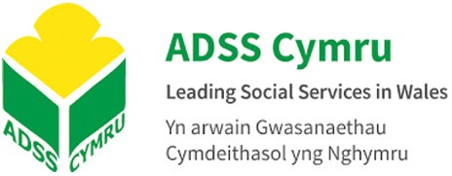
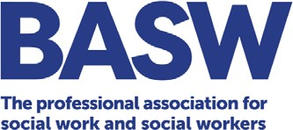

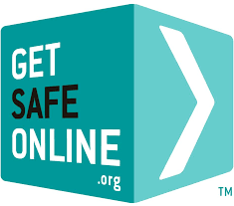
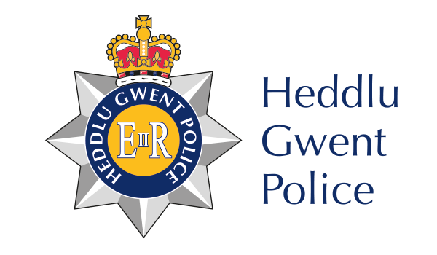
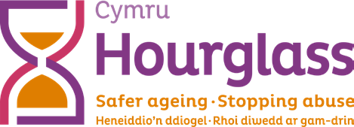

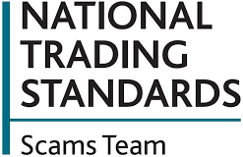
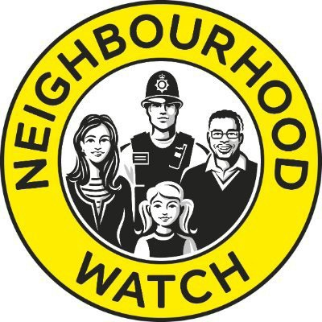
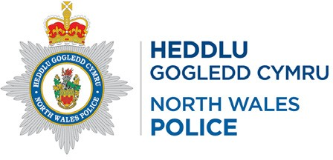

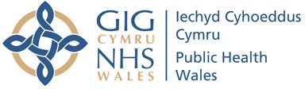
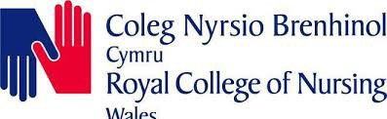

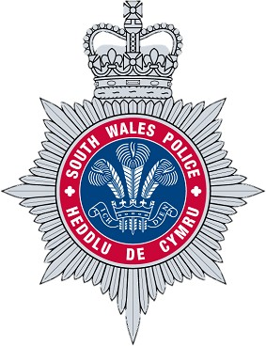
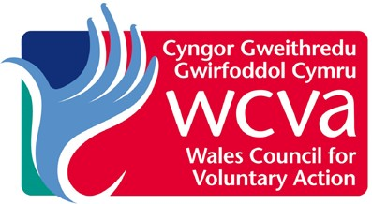
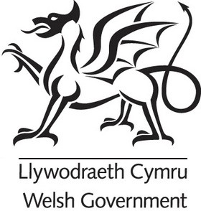
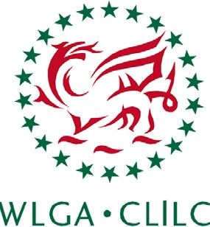
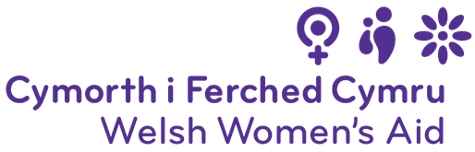

#GetHelpStaySafe #YouAreNotAlone

Contents

Introduction | 04
The impact of Covid-19 | 05
Protecting older people from abuse | 06
Recognise the signs of abuse | 06
Get help and support | 07
Protecting older people from crime, fraud and scams | 09
What to look out for | 09
Stop. Challenge. Protect | 10
Get help and support | 11
Get the information you need | 12
Useful Contacts | 13
Action Group Members | 13
Local authority contacts | 15

.....................................................................................................................................

Introduction
The Covid-19 pandemic has caused significant concern and disruption for us all. But for older people at risk of or experiencing abuse, and those who have been the victims of crime or targeted by criminals, the recent months will have been incredibly difficult. Many older people throughout Wales will have felt frightened, isolated and alone.
That’s why we’ve come together with a simple message for older people in Wales: You are not alone. We’re here for you and we can help and support you.
We’re working together to make sure that older people who may be at risk, and those who care for and care about them, have the information they need about the help and support available. We’re also working to raise awareness amongst the wider public about the role we can all play in helping to protect older people.
This pack provides a range of useful information and resources about keeping older people safe – including the ways we can identify older people who may be at risk, and contact details for key organisations that can provide crucial help and support.
Thank you for your support in protecting and safeguarding older people throughout Wales.

The impact of Covid-19
We know that the Covid-19 pandemic has been a particularly difficult time for older people living with abuse, and that the lockdown measures currently in place are also creating situations where older people may be at greater risk of abuse.
Under the current measures, many of the usual opportunities to identify abuse – through contact with professionals at routine appointments, for example – have been lost, which means that older people could be missing out on potentially life- saving help and support.
We can all play a role in protecting older people and it’s crucial that we look out for the signs that an older person may be experiencing, or at risk of, abuse.
Despite the disruption, help and support is still available. Safeguarding teams and support services are still up and running, investigating concerns and ensuring that people get the help they need so they are safe.
Anyone who has concerns about an older person should contact their local council’s safeguarding team (contact details on page 15) or their local police on 101 (in an emergency, dial 999).
Details of organisations that can provide help, advice and support to people who are experiencing abuse or are at risk, or those who have concerns about someone, are also included below (page 7).
In addition, we know that criminals are using the current situation to exploit and defraud people, and that many criminals are specifically targeting older people due to their perceived vulnerability.
We’re also seeing online crimes and scams relating to Covid-19 and, with more of us than ever using the internet to keep in touch with family and friends, shop and entertain ourselves, it’s crucial that we do all we can to keep ourselves safe online.
We’ve included information below about how older people can protect themselves against criminals and the things to look out for (page 9), and details of organisations that can provide help and support (page 11).

Protecting Older People From Abuse

Recognise the signs of abuse

Domestic abuse may include violence, psychological, sexual, financial and emotional abuse, and patterns of coercive and controlling behaviour. Threats to other family members or family pets can also be a form of abuse.
While our contact with others is limited at this time, there are still signs we can all look out for that could indicate someone is experiencing abuse:
- Physical signs, such as unexplained bruising or injuries
- Changes in behaviour
- Becoming withdrawn
- Not leaving the house (even for daily exercise)
- Changes in contact with family or friends
- Changes in the way someone uses social media

If you are concerned that an older person is experiencing, or at risk of, abuse, contact your council’s safeguarding team (see page 15) or call your local police on 101 (in an emergency dial 999).
999 Silent Solution
In an emergency, it’s crucial to contact the police for help. But in some cases, speaking to a 999 operator may put an individual in even greater danger.
In situations where someone needs help but is unable to talk, they should dial 999 and press 5 5 when prompted by the operator. Help will be sent to their location.

Get help and support
We know that it may be incredibly difficult to seek help if you are experiencing abuse or are at risk, but it is important you get help if you need it. There is no need to suffer in silence – help is available to protect and support you.

Hourglass Cymru (formerly Action on Elder Abuse Cymru)
The Hourglass Cymru Helpline offers support specifically for older people and can provide information, help and support, whether you are experiencing abuse or are concerned about someone else.
0808 808 8141
https://www.wearehourglass.cymru/wales

‘Home shouldn’t be a place of fear’ campaign // Live Fear Free
The Welsh Government’s ‘Home shouldn’t be a place of fear’ campaign aims to let those at risk of domestic abuse, sexual violence and coercive control know that help is still available 24 hours a day, every day, via Live Fear Free, and reach anyone still in a position to help those who may be at an increased risk.
You can find out more about the campaign and access resources and online learning here:
https://gov.wales/live-fear-free/staying-safe-during-coronavirus-emergency
Live Fear Free provides 24-hour help and support to people experiencing abuse, and those who are concerned about others.
0808 8010 800
https://gov.wales/live-fear-free

Training for Key Workers and Volunteers
Aberystwyth University’s Dewis Choice initiative has developed a new online domestic abuse training course to ensure that key workers and volunteers have the skills and knowledge they need to recognise potential abuse and ensure that people get the help and support they need.
The training is focused specifically on older people and their needs, and covers a range of areas including the ways in which older people may experience domestic

abuse, the barriers that may prevent an older person seeking help, and the impact of abuse on people’s mental health and well-being.
We would urge anyone who may come into contact with older people through their work or volunteering role to complete the Dewis Choice training.
Contact choice@aber.ac.uk to find out more.

Protecting older people from crime, fraud and scams

What to look out for

We know that criminals are using the current situation to exploit and defraud people and that older people are often targeted specifically by criminals due to their perceived vulnerability.

But by knowing what to look out for, we can protect ourselves and others from becoming victims of crime.
Criminals are experts at impersonating people, organisations and the police. They can contact you by phone, email, text, on social media, or in person. They will try to trick you into parting with your money, sharing personal information, or buying goods or services that don’t exist.
Many scams and frauds are designed to get you to open or click on links in emails, go to fake websites, or respond to text messages, where you will be asked to provide personal or financial details that the criminals will use to take your money.
We’ve highlighted some of the Covid-19 related scams we’re seeing below:
- Online shopping scams where people have ordered protective face masks, hand sanitiser, Covid-19 testing kits, and other products, which have never arrived.
- Suspects asking for a donation to tackle Covid-19, normally via email, or pretending to be from a charity which is assisting vulnerable people during the outbreak.
- Victims receiving a call with an automated message purporting to be from the government, stating that all individuals now need to wear a face mask when they leave their residence. The message tells the victim to press 1 in order to purchase a mask.
- Text messages are being sent to recipients, purporting to be from HMRC, advising they can get a tax refund of up to £400. This text features a link to a fake government website where the recipient can determine whether they are eligible for a refund.

- Emails purporting to be from the World Health Organization (WHO) are informing recipients that they have been selected to receive a grant of
$15,000 due to the outbreak. A follow-up email address is provided for recipients to seek further details.
- Reports of emails purporting to be from Virgin Media, informing recipients that their bill is ready to view. The emails include information on how Virgin Media are responding to the COVID-19 outbreak. The bill amount commonly equates to £60.78.

Stop. Challenge. Protect

We can all take action to protect ourselves against crime and scams. If you are contacted unexpectedly, remember to:
- Stop: Take a moment to think before parting with your money or information could keep you safe.
- Challenge: Could it be fake? It’s ok to reject, refuse or ignore any requests. Only criminals will try to rush or panic you.
- Protect: Contact your bank immediately if you think you’ve fallen victim to a scam and report it to Action Fraud (details below).

The police, or your bank, will never ask you to withdraw money or transfer it to a different account. They will also never ask you to reveal your full banking password or PIN.
Do not click on links or attachments in unexpected or suspicious texts or emails.
Confirm requests are genuine by using a known number or email address to contact organisations directly.
You can also report suspicious texts by forwarding the original message to 7726, which spells SPAM on your keypad.

Get help and support
You shouldn’t feel embarrassed about reporting a crime where you’ve been scammed – scammers are clever and scams can happen to anyone.
If you have been scammed, there are organisations you should report the scam to, which helps to track down and stop scammers and prevents other people from being scammed.

Contact the Police: You should contact the police immediately by calling 101 if the scammer is in your area, or if you have transferred money in the last 24 hours. If you feel threatened or unsafe, you should call 999.

Contact Action Fraud: You should report all types of scams to Action Fraud, the UK’s national reporting centre for fraud.
Action Fraud can get the National Fraud Intelligence Bureau to investigate scams and will also give you a crime reference number, which can be helpful if you need to tell your bank you’ve been scammed.
0300 123 2040
Textphone: 0300 123 2050 https://www.actionfraud.police.uk/reporting-fraud-and-cyber-crime
Contact Citizens Advice:You can also report scams to Citizens Advice. They collect information about scams which is shared with Trading Standards, who investigate and, where possible, prosecute scammers.
03444 77 20 20

Report an online scam here: https://bit.ly/2AzKqHf

Report an offline scam (e.g. doorstep or telephone scam) here: https://www. citizensadvice.org.uk/consumer/get-more-help/if-you-need-more-help-about- a-consumer-issue/

Get the information you need

Action Fraud
Action Fraud has a wide range of information and resources about what to look out for, including an A to Z of fraud and information on how we can protect ourselves.
0300 123 2040
https://www.actionfraud.police.uk/

Friends Against Scams
Friends Against Scams is a National Trading Standards Scams Team initiative which aims to protect and prevent people from becoming victims of scams by empowering people to take a stand against scams.
By completing the Friends Against Scams online learning, anyone can learn about the different types of scams and how to spot and support a victim.
With increased knowledge and awareness, people can make scams part of everyday conversation with their family, friends and neighbours, which will enable them to protect themselves and others.
https://www.friendsagainstscams.org.uk/

Get Safe Online
Get Safe Online provides practical advice on how to protect yourself, your computers and mobile devices against fraud, identity theft, viruses and many other problems encountered online.
Visit the Get Safe Online website to get information and guidance on a wide range of topics that will help you to use the internet safely, as well as useful tips and updates on the latest online scams to look out for, including Covid-19 related scams.
www.getsafeonline.org

Useful Contacts

Action Group members
A number of the organisations working together to protect and safeguard older people in Wales can provide help and support. You can find their contact details below:
Age Cymru
Age Cymru is the largest charity working with and for older people in Wales. They campaign, research and fundraise to build a better life for all older people.
Age Cymru’s Advice Line provides free confidential, impartial, simple information and advice on a range of matters, while their newly-launched ‘Check in and Chat’ service connects people over 70 with volunteers who provide reassurance, answer basic queries and link people to local services and support during the Coronavirus pandemic.
08000 223 444
www.agecymru.org.uk

Hourglass Cymru (formerly Action on Elder Abuse Cymru)
Hourglass Cymru (formerly Action on Elder Abuse Cymru) is the only national charity dedicated to calling time on the harm and abuse of older people.
They support those experiencing (or at risk of) harm, as well as raising awareness and advocating effective prevention. They work exclusively on challenging
the abuse of older people in all its forms, in all settings, whether that abuse is perpetrated by family members, partners, acquaintances, paid professionals or strangers. Their dedicated helpline can provide information, advice and emotional support to older people and those concerned about an older person.
0808 808 8141
www.wearehourglass.org

Live Fear Free Helpline
Live Fear Free provides 24-hour help and advice about violence against women, domestic abuse and sexual violence to people who are experiencing or at risk of abuse, and those who are concerned about others.
Tel: 0808 8010 800
https://gov.wales/live-fear-free

Older People’s Commissioner for Wales
The Older People’s Commissioner for Wales is an independent voice and champion for older people, working to protect and promote their rights and influencing policy and practice to improve their lives.
Contact the Commissioner’s Casework Team for advice and support on a range of matters.
03442 640 670
www.olderpeoplewales.com

Local authority contacts

Blaenau Gwent County Borough Council
01495 311556
Safeguarding Team: 01495 315700
https://www.blaenau-gwent.gov.uk/en/resident/emergencies-crime-prevention/ coronavirus-covid-19-latest-information/

Bridgend County Borough Council
01656 643643
Safeguarding Team: 01656 642279
https://www.bridgend.gov.uk/my-council/council-priorities-and-performance/ coronavirus-covid-19-latest-information-and-advice/

Caerphilly County Borough Council
01443 815588
Safeguarding Team: 0808 100 2500 https://www.caerphilly.gov.uk/Coronavirus Cardiff Council
029 2087 1071
Safeguarding Team: 029 2233 0888
https://www.cardiff.gov.uk/ENG/Your-Council/Strategies-plans-and-policies/ Emergency-Planning-and-Resilience/coronavirus-information/Pages/default.aspx

Carmarthenshire County Council
01267 234567
Safeguarding Team: 01267 228944
http://newsroom.carmarthenshire.gov.wales/2020/02/coronavirus-covid-19-
guidance

Ceredigion County Council
01545 570881
Safeguarding Team: 01545 574000 https://www.ceredigion.gov.uk/coronavirus Conwy County Borough Council
01492 574000
Safeguarding Team: 0300 456 1111
https://www.conwy.gov.uk/en/Spotlight/Press-Releases/Council-Services-Current- Situation-180320-1000hrs.aspx

Denbighshire County Council
01824 706000
Safeguarding Team: 0300 4561000
https://www.denbighshire.gov.uk/en/resident/community-and-living/coronavirus/ coronavirus.aspx

Flintshire County Council
01352 752121
Safeguarding Team: 03000 858858
https://www.flintshire.gov.uk/en/Resident/Emergency-Planning/Coronavirus-Covid- 19-council-services-update.aspx

Gwynedd Council
01766 771000
Safeguarding Team: 01766 772577
https://www.gwynedd.llyw.cymru/en/Residents/Emergencies/Coronavirus-Covid- 19-Our-services.aspx

Isle of Anglesey County Council
01248 750057
Safeguarding Team: 01248 752752
https://www.anglesey.gov.uk/en/Residents/Emergencies/Covid-19-Coronavirus- information.aspx

Merthyr Tydfil County Borough Council
01685 725000
Safeguarding Team: 01685 725000 https://www.merthyr.gov.uk/coronavirus Monmouthshire County Council
01633 644644
Safeguarding Team:
01600 773041 (Monmouth/Usk/Raglan)
01873 735885 (Abergavenny)
01291 635666 (Chepstow/Caldicot)
https://www.monmouthshire.gov.uk/services/planning-for-emergencies/ coronavirus/

Neath Port Talbot County Borough Council
01639 686868
Safeguarding Team: 01639 685378 https://www.npt.gov.uk/22404 Newport City Council
01633 656 656
Safeguarding Team: 01633 656 656
http://www.newport.gov.uk/en/Council-Democracy/Coronavirus-COVID-19.aspx

Pembrokeshire County Council
01437 764551
Safeguarding Team: 01437 764551 https://www.pembrokeshire.gov.uk/advice-on-the-coronavirus Powys County Council
01597 827460
Safeguarding Team: 01597 827666
https://en.powys.gov.uk/coronavirus

Rhondda Cynon Taf County Borough Council
(Main switchboard repurposed due to Covid-19) Safeguarding Team: 01443 425003
https://www.rctcbc.gov.uk/EN/Resident/ EmergenciesSafetyandCrime/InformationforResidentsCoronavirus/ CoronavirusCOVID19latestinformationandadvice.aspx

City and County of Swansea Council
01792 636000
Safeguarding Team: 01792 636854 https://www.swansea.gov.uk/coronavirusadvice Torfaen County Borough Council
01495 762200
Safeguarding Team: 01495 762200
https://www.torfaen.gov.uk/en/AboutTheCouncil/Homepage-Stories/COVID-19- Coronavirus.aspx

Vale of Glamorgan Council
01446 700111
Safeguarding Team: 01446 700111
https://www.valeofglamorgan.gov.uk/en/our_council/press_and_communications/ latest_news/Coronavirus/Coronavirus-Updates-2020.aspx

Wrexham County Borough Council
01978 292000
Safeguarding Team: 01978 292066
https://beta.wrexham.gov.uk/coronavirus

